Transformers Algorithm Based University

Query Bot

Anusri K1

*dept. of Information Technology  
Sri Krishna College of Technology*  
Coimbatore, India  
anusri.k2019@gmail.com

Rajeshkumar C4

*dept. of Information Technology  
Sri Krishna College of Technology*  
Coimbatore, India  
Corresponding Author:

rajeshkumar.c@skct.edu.in*

Janani B S2

*dept. of Information Technology  
Sri Krishna College of Technology*  
Coimbatore, India  
bsjanani479@gmail.com

Kaviya S3

*dept. of Information Technology  
Sri Krishna College of Technology*  
Coimbatore, India  
kaviyacbe2002@gmail.com

*Abstract*—The project aims to create and implement an AI-based chatbot for the WhatsApp platform, utilizing Artificial Intelligence and Machine Learning algorithms. We plan to implement an AI-based virtual assistant to address college-related queries. This College-Oriented Intelligence machine will respond to students' queries, enhancing the efficiency and effectiveness of existing online AI systems and chat bots. The chatbot is integrated using the WhatsApp Business API and is designed to provide teachers, students, and parents with comprehensive information about academic details, attendance, and overall performance. This chatbot is particularly beneficial for universities, as it addresses parents questions using the AI in the bot, trained using the Pre Trained Transformer Based Deep Learning Algorithm and Natural Language Processing.

Keywords—Artificial Intelligence, WhatsApp Business Application Programming Interface, Natural Language Processing.

# Introduction

WhatsApp AI chatbots have revolutionized customer interaction on the messaging platform. These Artificial Intelligent bots use Machine Learning algorithms , Natural Language Processing and predefined rules to provide personalized, efficient service. With over 2 billion active users worldwide, WhatsApp offers an extensive user base for businesses to engage with. Chatbots can handle customer inquiries, offer support, provide information, and assist in purchases or bookings within the messaging interface [4]. They excel in e-commerce, where they streamline the shopping experience by offering product information, assisting in product search, processing orders, and shipping updates and also healthcare Industries [2]. In customer service, they handle questions, and help them in troubleshooting the issues, and escalate complex queries to human service providers when necessary. WhatsApp AI chatbots utilize a combination of NLP models, machine learning algorithms, and APIs for functionality. NLU models aid in understanding user intents, while machine learning improves accuracy and performance [13]. APIs enable integration with external systems, allowing chatbots to access databases and perform specific actions.

A WhatsApp AI chatbot is developed through defining objectives, designing conversation flows, setting up Natural Language Processing models, training the bot using datasets, testing it for accuracy, and deploying it via the WhatsApp Business API or third-party platforms that support WhatsApp integration. WhatsApp AI chatbots offer numerous benefits to businesses, including round-the-clock support, reduced response time, and enhanced user engagement. They also provide valuable insights by analysing user interactions, which can inform business strategies and improve customer experiences [10]. As technology advances, the capabilities of WhatsApp AI chatbots continue to evolve, with the integration of voice recognition, sentiment analysis, and sophisticated AI models promising more robust and personalized interactions [5]. These powerful tools streamline communication, provide efficient customer service, and enhance user experiences on the popular messaging platform, shaping the future of customer engagement and service delivery.

This University Query Bot system, designed using Transformers algorithm and integrated into Facebook meta Developers Account and WhatsApp API, aims to provide students with a conversational experience with college staff, Parents and Students [1].The system addresses queries through text, pictures, and other features. The project focuses on an intellectual chatbot system which handles the queries related to the admission enquiries, fee structure, scholarship details, department timetables, overall performance and required documents [3]. This system aims to make it easier for students and parents to clear their queries in less duration.

# Literature Survey

1 . Almost every industry in healthcare has seen a rise in the use of chatbots as a result of the development and enhancement of ICTs. Additionally, in the medical field, technology has altered how doctors and patients communicate. Due to their high efficiency and low cost, chatbots are now employed in computerized medical communication to replace human agents. Two revolutionary technologies that have transformed the way doctors and patients view healthcare are chatbots and artificial intelligence (AI). Artificial Intelligence (AI) has been investigated in the healthcare industry for the purpose of automating public user appointments and applications. A WhatsApp chatbot is a software that can automatically respond to messages on the messaging app . The primary goal of this project is to improve interaction, effective communication and to make a diagnostic chatbot which works based on machine learning algorithms. It helps the patients in booking, scheduling, cancelling the Doctor’s appointment. With the help of an artificial chatbot, the suggested work would be able to conduct live chats with patients and users about scheduling appointments with the relevant doctors [20]. It is possible to expand the use of this application beyond business-to-consumer (B2B) to business-to-consumer (B2C), allowing service providers such as physicians, physiotherapists, psychologists, ayurvedic doctors, dieticians, nutritionists, and trainers to target individual customers.

2. Living in an era of ongoing technological innovation means that, as a result of the digitalization process, technology is becoming an inevitable part of daily life. An artificial intelligence (AI)-driven system used to support customer service in the travel, business, or educational sectors is known as a chatbot. It determines the effectiveness and efficiency of an organization's performance. However, a few people find it awkward to use chatbots [16]. This is the outcome of their failure to find alternatives to their problems. The factors impacting college students' preparedness to use chatbots are examined in this study. A questionnaire was used to collect responses, which were then shared across social media platforms like WhatsApp, Instagram, Twitter, and Line. Intelligent PLS 4.0 was then used to analyze the data. The results demonstrate that perceived trustworthiness, perceived simplicity of use, and perceived usefulness.

3. One of the most popular AI solutions for improving educational activities is the chatbot system. Clari zi a et al. (2018) state that chatbots are considered a useful tool for improving classroom instruction [8]. In the era of the Fourth Industrial Revolution (4IR), educators can oversee learning through an online or classroom platform by utilizing a range of technological tools, such as chatbot systems.

4. In Indonesia, hoaxes are spreading more widely as a result of the growing usage of social media. For Indonesians, there are a number of anti-hoax applications available to help combat this. These applications are still not widely used, despite being freely accessible. Because of the application's poor interaction design—which makes it hard to use, confusing, etc.—people rarely use it [11]. Consequently, the low usage rate is driving up the need to address the application's interaction design immediately. This research aims to develop an application's interaction design that can solve users' issues and boost the anti-hoax application's usage rate. A chatbot on the WhatsApp app has been selected as the platform for the solution. The anti-hoax chatbot's interaction design was created using the user-centered design approach, which puts the needs and issues of the user front and center. The study produced a high-fidelity prototype that satisfies the user experience and usability goals with regard to being helpful and simple to use.

5. The Chat Fuel platform is used to build and propose the chat-bot system, which is then integrated into a Facebook page. The chatbot's goal is to give students the impression that they are having a conversation with college officials by responding to their inquiries using natural language. The user can receive text responses, picture responses, and a plethora of other Chat Fuel features. The bot is sophisticated and can answer questions from users thanks to the AI feature that has been set up [20]. This project's development is centered around an intelligent chatbot that handles inquiries about admission, the cost structure, information about scholarships, departmental schedules, and the specific documents that must be attached, among other things [18]. It will be possible to use this chat-bot system to clear the queries in lesser time .

# Problem Statement

There are a several methods for contacting colleges for enquiries, but each has drawbacks. Students or parents may receive contradictory information from several staff members or departments, which can cause confusion and annoyance. Students and parents may find it challenging to receive prompt assistance from certain systems of inquiry, particularly when it's after usual business hours [15]. These systems may only be accessible at specific times or through particular channels. Inadequate training or resources may be provided to staff personnel in charge of the system of inquiry, which could result in inconsistent or inaccurate responses. Group members may find it challenging to locate pertinent material or participate in fruitful discussions when conversations regularly stray from the subject at hand. Linguistic differences might cause misconceptions or communication problems within ethnic collegiate campuses. If private things are disclosed without permission, such as private conversations or contact details, group members' privacy may be affected. The hectic pace of the group chat might cause noteworthy announcements or messages to get lost, leaving users without essential data. Members of large groups may find it difficult to participate fully in discussions or keep track of conversations.

Navigating the college inquiry system can be difficult for parents, particularly if it is complicated or has a poorly designed interface. It can be intimidating to know how to conduct research, find pertinent resources, and send questions. Parents might experience trouble setting up accounts and logging in, or recovering lost passwords, which makes it more difficult for them to get important information. Interacting with university admissions executives, financial aid consultants, and other faculty and staff can be challenging for parents, particularly if they are not familiar with college nomenclature or procedures. When utilizing the college enquiry system, users may experience technical problems or faults such as malfunctioning links, site goes down, or problems with their smartphones or web browsers compatibility. These problems may impede their capacity to efficiently obtain information or make queries. It may be more difficult for parents from underprivileged homes or the ones with inadequate access to facilities to learn about colleges and successfully complete the application procedures.

# Existing System

The Watson Chatbot can also be tailored to meet particular college requirements, which helps to ensure that everyone involved has a smooth and cutting-edge learning experience.It can help students choose courses, give advice on academic planning, and even help faculty with administrative duties. It can also provide information about campus resources. Because of its seamless integration with current college systems, the chatbot can access and retrieve real-time data, guaranteeing that the information it provides is correct and current. The adaptability and scalability of the IBM Watson Chatbot are important features. Colleges can modify the chatbot to represent the distinct character and needs of their school, giving users a personalized experience. Because of its versatility, the chatbot can be accessed via different platforms like websites and mobile applications, so it can interact with teachers and students wherever they feel most at ease. By utilizing the potent powers of IBM Watson, the chatbot offers instructors and students an easy-to-use interface through which they can obtain information, get help, and have interactive discussions [17]. The chatbot can comprehend and reply to a variety of questions, from course-related enquiries to administrative procedures, thanks to machine learning and natural language processing algorithms. This technology improves efficiency and creates a more responsive and connected campus environment by streamlining communication, automating repetitive tasks, and providing individualized support.

The Watson Chatbot can also be tailored to meet particular college requirements, which helps to ensure that everyone involved has a smooth and cutting-edge learning experience. It can help students choose courses, give advice on academic planning, and even help faculty with administrative duties. It can also provide information about campus resources [8]. Because of its seamless integration with current college systems, the chatbot can access and retrieve real-time data, guaranteeing that the information it provides is correct and current. It generates a conversational flow assistant powered by AI that makes use of the best AI capabilities available in the market to comprehend inquiries from clients in plain language.

To provide precise answers instantly, it builds custom machine learning models using your data. Connects up with the customer support departments. Connect customers with live agents from your current service desk provider if they require additional assistance or wish to talk about a matter that needs personal attention. Clients communicate with the helper via one or more of these channels: An already-existing social media messaging service like WhatsApp, Facebook Messenger, or Slack .A text message or phone call. An integrated web chat feature that allows you to forward complex inquiries to a customer support agent on your business website. A unique application that you create, like a voice-activated robot or a mobile application. After receiving a message from a customer, the assistant forwards it along the proper resolution path [14]. This is where you would use webhooks to inject logic to call an external service that can process the incoming messages before the assistant routes them, if you wanted to preprocess them.

Similarly, it has the ability to handle the assistant's answers before giving them back to the client. Takes the helper to your clients' locations. Sets up one or more of the integrated integrations to quickly post your assistant on widely used social media sites like WhatsApp, Facebook Messenger and Intercom. Makes the assistant a part of your customer service call centre team so that its human coworkers can concentrate on more complex customer needs. The assistant can take care of basic phone calls and inquiries. By including your assistant as a chat widget on your business website, you can position it as the go-to help source for clients [19]. Uses the APIs to create a custom app if none of the pre-integrated ones work for you. With every aspect considered, the IBM Watson Chatbot for College is a complete solution that blends state-of-the-art AI technology with customization and adaptability, ultimately creating an environment that is more effective, personalized, and engaging for both faculty and students [9].

# Proposed Method

The project aims to establish a chatbot between users and colleges using artificial intelligence to respond to users queries like attendance, college events, overall performance etc. The chatbot will use natural language processing technologies to process text input, which will undergo parsing, tokenization, and stemming. By using the stored data in a JSON file format for queries, responses, crucial messages, current and previous log files, the transformers algorithm, a NLP technique, is trained to match responses and output text [6].

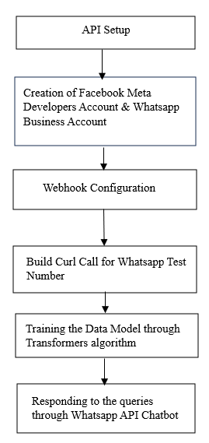

Fig. 1.Work Flow of the proposed system

It uses Python as the language, as it is user-friendly and has object-oriented concepts. The Artificial Neural Network (Pre Trained Transformer) algorithm will be used. The chatbot utilizes artificial intelligence to provide appropriate answers to user queries related to college activities, eliminating the need for users to physically visit the college for inquiries [10]. The query is analyzed and the information drawn out for matching the data with the appropriate knowledge base. The chatbot is integrated with WhatsApp Business API Platform, allowing users to post queries. The output will be displayed on the WhatsApp API Business Platform, allowing users to ask queries.

# Methodology

The chatbot employs Natural Language Processing (NLP) through the Transformers Algorithm, utilizing data saved in JSON files that contains questions, responses, significant messages, current and past log records empowering the framework to match reactions and result message.

## Data Collection and Preprocessing

The student’s attendance, academic performance and college related events, examination, fees structure related data will be collected and stored in JSON file. The collected data will be utilized to train the model by using transformer algorithm. The queries are preprocessed to retrieve the necessary keywords for a suitable response. Text preprocessing in natural language processing involves cleaning and preparing text data using Natural Language Toolkit (NLTK), Bidirectional and Auto-Regressive Transformer (BART) and Torch Python libraries.

## Data Segmentation

Transformers are natural language processing algorithms for chatbots that automatically process large amounts of natural language data [12]. They are based on statistical models and learn patterns in data. Transformers capture context and relationships efficiently, excelling in NLP tasks like chatbots, machine translation, sentiment analysis, image recognition, and object detection. Separate the entire dataset (for example, 80% training and 20% testing) into sets for training and testing. Huge, real-time, reliable data is needed for a chatbot to answer efficiently[7].

## API Setup

Python's FASTAPI web framework is used for API setup. Then Facebook meta developers account and WhatsApp business account is created. Recipient mobile number is added to send and receive messages. Create the app in my apps called Bot in business account. Temporary access is available. Send and receive messages through test phone number. We can send the messages to recipient phone number through given test phone number [9]. To send a text message with the API through curl call creation.

## Curl Call

A user can specify a server URL and the information they wish to transmit to that server URL by using this command line interface (CLI).

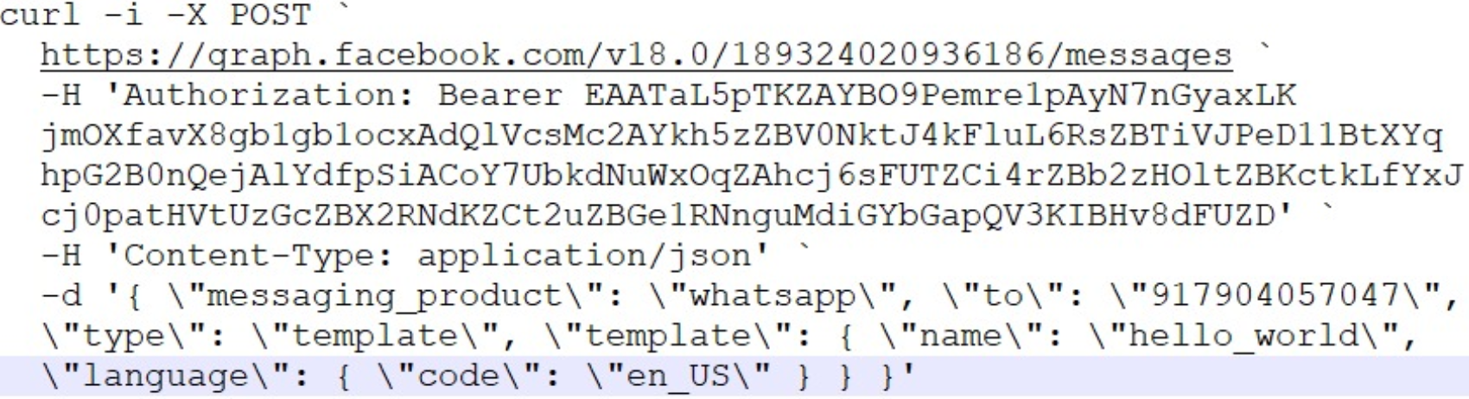

Fig. 2. Execution of Curl Call

## Webhook Configuration

Next step is to configure webhook endpoint URL that is our API endpoint URL to receive messages and then enable the webhook fields, messages, images, documents etc. Webhooks are messages that apps automatically send out when anything occurs. They are directed to a particular URL, which is simply the address or phone number of the application, with a message. Apps can communicate with other apps automatically by sending data or messages using webhooks.

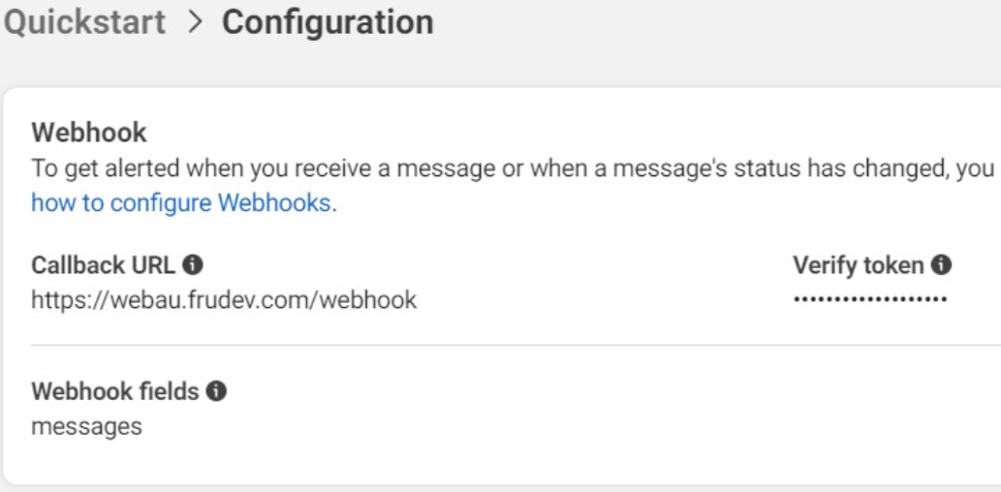

Fig. 3. Configuring Webhook

## Data Model Training

A Neural network architecture called Transformer is intended to handle problems involving natural language processing. Transformer networks analyse and comprehend the context of words in phrases using a technique known as the attention mechanism in order to extract relevant information from them.

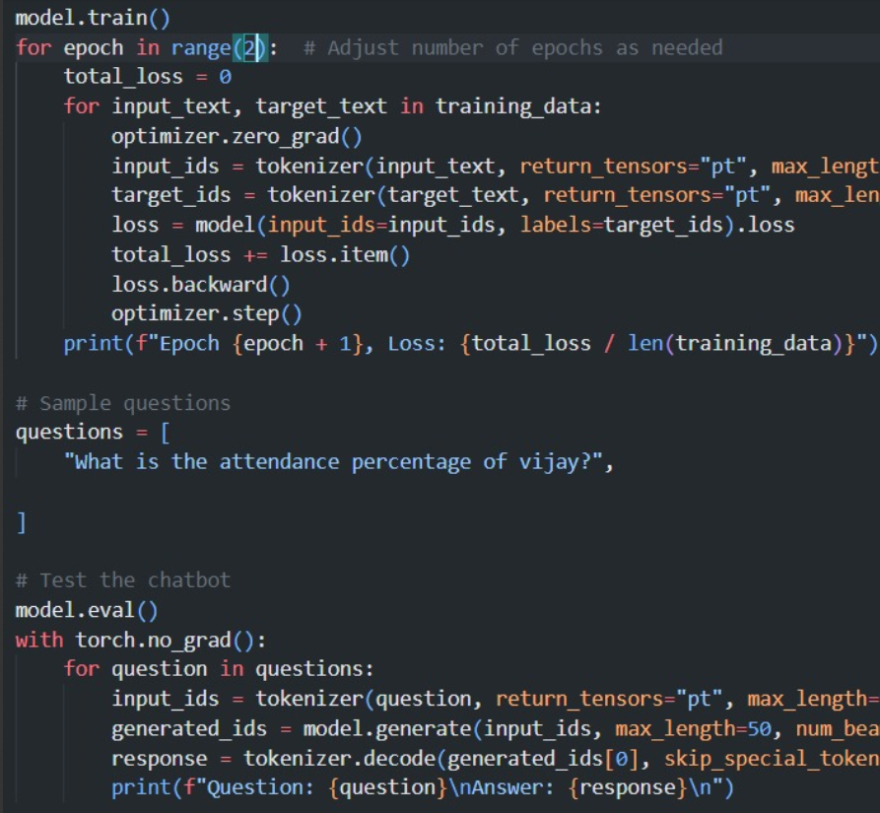

Fig. 4. Training the model using Transformers Algorithm

Transformers are more formidable and broadly applicable than earlier architectures because they can be successfully trained on significantly larger datasets and constructed with far more attributes. Training speed is increased as the attention mechanism can be computed for all tokens in parallel because it only requires data on various tokens from previous levels. Neural network architectures known as transformers are designed to convert a sequence of inputs into a series of outputs [16]. The Transformers algorithm is trained with the JSON data file using python libraries. Every inquiry that parents and students might possibly have is loaded into a JSON object.

## Performance Evaluation

To obtain an accurate response, the algorithm is run several times. To assess the accuracy of the answers, questions are asked. To get accuracy, the model undergoes many training sessions using distinct sets of questions and all feasible answers.[17] The WhatsApp chatbot accepts the queries related to the training and testing datasets, and responds to the users.

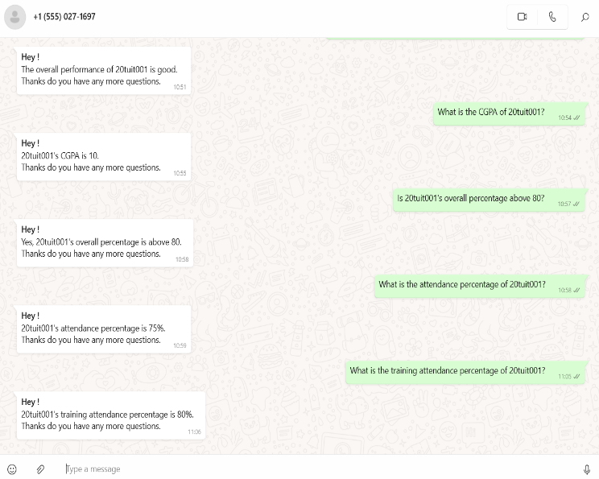

Fig. 4. Sending Queries and receiving responses from the chatbot

# Result

The Proposed method's implementation has produced encouraging results, which is a big step in the direction of building a more effective inquiry system. Transformers have shown to be a competitive alternative to Recurrent neural networks and Long short-term memory algorithm for tasks that are sequential owing to their capacity for parallel processing, capacity to capture long-range dependencies, and enhanced resource utilization [12]. A WhatsApp chatbot for that's compatible with the platform to give consumers a smooth experience. The WhatsApp Business API features supports two-way communication. The chatbot provides a range of features, such as transaction assistance, assistance with queries, and data. Large-scale testing guarantees accuracy and dependability. When the chatbot is deployed, it expedites the speed of response, improves client engagement, and simplifies processes. Iterative improvements are possible with continuous monitoring.

Using chatbots incorporated inside WhatsApp will make it easier for parents to use, saving them the trouble of creating accounts and checking in to access chatbots that are integrated within college websites or other mobile applications. Comparing to other approaches of setting up WhatsApp groups for inquiry, which cause turmoil among members and compromise students' privacy by sending sensitive information, WhatsApp chatbot protects user privacy and offers a seamless inquiry process. The outcome is an advanced chatbot that surpasses customer demands and provides ease of use, efficiency, and contentment.

# conclusion and future enhanchment

To conclude, University Query Bot assists in providing parents and students with accurate and current information regarding their academic progress, performance, etc. This chatbot uses Artificial Intelligence and a knowledgeable database to inform students about their college activities. The proposed system aims to provide user-submitted questions with responses based on user input. It aims to create an interface and database to record data on questions, responses, keywords, and invalid questions. The system uses Transformers Algorithm, a NLP technique for improved performance and accuracy. Faster user inquiry responses and less labor for college staff are the major objectives.

The system prioritizes performance, accuracy, privacy and fast response times. The chatbot aims to transform pattern matching and virtual assistance by converting humans into machines and answering user queries. The chatbot uses sentiment analysis to recognize user queries, such as positive, negative, and neutral, and stores all conversations in the database. However, the system has only partially succeeded in adding empathy due to the vast scope of queries and the need for more rigorous data to handle off-script questions. The chatbot will be expanded in the future by adding data from all departments, training it with a variety of data, testing it on an operational website, and adding more training data in response to user input.

##### References

1. Pradeep Udupa,”Application of artificial intelligence for university information system”,Engineering Applications of Artificial Intelligence,Volume 114,2022,105038,ISSN 0952-1976.
2. Kaladevi, S. Saidineesha, P. Keerthi Priya, K. M. Nithiya and S. Sai Gayatri, "Chatbot For Healthcare Using Machine Learning," 2023 International Conference on Computer Communication and Informatics (ICCCI), Coimbatore, India, 2023, pp. 1-4.
3. X. Gonsalves and S. Deshmukh, "Designing an Interactive Chatbot for Educational Assistance using Rasa Framework," 2023 International Conference on Intelligent Data Communication Technologies and Internet of Things (IDCIoT), Bengaluru, India, 2023, pp. 68-74.
4. A. Kiran, I. J. Kumar, P. Vijayakarthik, S. K. L. Naik and T. Vinod, "Intelligent Chat Bots: An AI Based Chat Bot For Better Banking Applications," 2023 International Conference on Computer Communication and Informatics (ICCCI), Coimbatore, India, 2023, pp. 1-4.
5. Khadija A, Zahra FF, Naceur A. AI-powered health chatbots: toward a general architecture. Procedia Comput Sci. 2021; 191: 355-60. doi: 10.1016/j.procs.2021.07 .048.
6. Uzwyshyn, Raymond. (2024). New Horizons in AI for Libraries (Section Introduction): Projects in Machine Learning and Natural Language Processing in Libraries. 10.13140/RG.2.2.16035.63525.
7. A. K. Nikhath et al., "An Intelligent College Enquiry Bot using NLP and Deep Learning based techniques," 2022 International Conference for Advancement in Technology (ICONAT), Goa, India, 2022, pp. 1-6.
8. Chinedu Wilfred Okonkwo, Abejide Ade-Ibijola,Chatbots applications in education: A systematic review,Computers and Education: Artificial Intelligence,Volume 2,2021,100033,ISSN 2666-920X,
9. D. Chakraborty, A. Mishra, V. Kumar, S. Singh and H. Hani, "VOID - An Assistant (Chatbot) to Education Queries System," 2022 International Conference on Advancements in Smart, Secure and Intelligent Computing (ASSIC), Bhubaneswar, India, 2022, pp. 1-6.
10. Ms.Ch.Lavanya Susanna, R.Pratyusha, P.Swathi, P.Rishi Krishna, V.Sai Pradeep, “College Enquiry Chatbot”, International Research Journal of Engineering and Technology (IRJET), e-ISSN: 2395- 0056, p-ISSN: 2395-0072, Volume: 07 Issue: 3 Mar 2020 pp 784- 788.
11. R. Daniel, A. Purwarianti and D. P. Lestari, "Interaction Design of Indonesian Anti Hoax Chatbot using User Centered Design," 2022 Seventh International Conference on Informatics and Computing (ICIC), Denpasar, Bali, Indonesia, 2022, pp. 1-6.
12. P.Nikhila, G.Jyothi, K.Mounika, Mr. C Kishor Kumar Reddy and Dr. B V Ramana Murthy on , “Chatbots Using Artificial Intelligence”, International Journal of Research and Development,Volume VIII, Issue I, January/2019, ISSN NO:2236- 6124, pp 1-12.
13. Kooli, Chokri. 2023. "Chatbots in Education and Research: A Critical Examination of Ethical Implications and Solutions" Sustainability 15, no. 7: 5614.
14. Adamopoulou, E., & Moussiades, L. (2020,June), “An overview of chatbottechnology”. In IFIP InternationalConference on Artificial IntelligenceApplications and Innovations (pp. 373-383). Springer, Cham.
15. Kranti Kolambe , Sai Date , Siddharth Nair, Tushar Raval, “College Query ChatBot”, International Research Journal of Engineering and Technology,2020,pp. 326-328.\
16. Eduardus Steven Sartono et al, “Exploring the Impact of Chatbot Functionality and Interactivity on Chatbot Usage Intention in Higher Education", 10th International Conference on Information Technology, Computer, and Electrical Engineering, 2023.
17. Dinh, Hoa, and Thien Khai Tran. 2023. "EduChat: An AI-Based Chatbot for University-Related Information Using a Hybrid Approach" Applied Sciences 13, no. 22: 12446.
18. Sunil Yadav, Sumit Srivastava, Syed Ali Auan, Vivek Kumar, “Admission Enquiry Chatbot System”,International Reasearch Journal of Modernization in Engineering Technology and Science,vol. 3,2021,pp. 2954-2958.
19. Harshala Gawade , Vedika Patil , Prachi Vishe , Sonali Kolpe, 2020, College Enquiry Chat-Bot System, INTERNATIONAL JOURNAL OF ENGINEERING RESEARCH & TECHNOLOGY (IJERT) Volume 09, Issue 09 (September 2020).
20. P. S, N. Balakrishnan, K. T R, A. J. B and D. S, "Design and Development of AI-Powered Healthcare WhatsApp Chatbot," 2023 2nd International Conference on Vision Towards Emerging Trends in Communication and Networking Technologies (ViTECoN), Vellore, India, 2023, pp. 1-6.